Software Release Notes
Version 1.0
1/14/2025
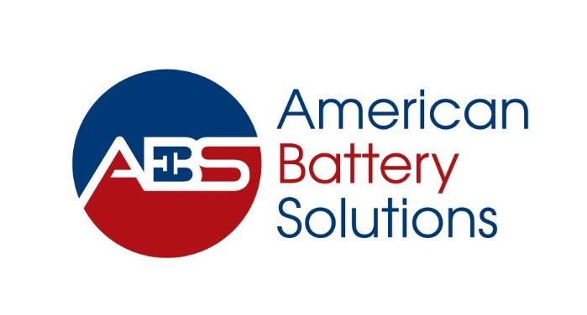

This procedure is the property of American Battery Solutions, it must not be reproduced in whole or in part or otherwise disclosed without prior written consent.
The official controlled copy of this quality manual is the digitally signed PDF document held within our network server and visible to all authorised users. All printed copies, and all electronic copies and versions, except the ones described above, are considered uncontrolled copies which should be used for reference only.

1 Project Description 2
2 Software Release Details 2
3 Changes 2
4 Open Issues 2
5 Implemented Change Requests 2
6 Fixed Defects 2
7 Memory and CPU Requirements 2

- Project Description
Bookshelf software component for S32k344 Mcal.
- Software Release Details
Release Date | 1/14/2025
Version | 1.0.14
Software Configuration Management Label | S32K344_MCAL_1_0_14_REL

- Changes
- Added all the pins (Adc,Gpio,EIRQ,FFCU) as per HSI 1.1.
- Configuration updates for ADC, EIRQ components.

- Open Issues
Issue ID | Summary

- Implemented Change Requests
Change ID | Summary

- Fixed Defects
Defect ID | Summary

- Memory and CPU Requirements
Memory Type | Available (bytes) | Used (bytes) | % Used
RAM
Flash
CPU Load(%)
Stack Required(bytes)

